

May 1st – Spirit Night at Pokey O’s Ice Cream 3-9p

May 7th – 11th: Teacher Appreciation Week

May 8th: Spirit Night at Culvers

May 10th: PTA Board Meeting 6pm

May 10th: General PTA Meeting 6:30pm

May 11th: Spring Carnival 6-8pm

May 14th – 16th: 3rd, 4th, 5th Grade STAAR Testing

May 18th: Kindergarten Popsicle Meet & Greet 6pm

May 18th: Spirit Night at Best Gymnastics

May 22nd – 24th: BOGO Book Fair

May 30th – Spirit Night at Marco’s Pizza

No School May 28th



It’s time for the Garden Ridge Annual Spring Carnival!

When: Friday, May 11th

Time: 6:00pm – 8:00pm

Cost: $10 if pre-ordered / $25 for family

$12 per wrist band at the door

Come dressed wearing your favorite Super Hero costume, cape, mask or come as yourself as you are a Super Hero!

Face-painting, studio art house crafts, jumpy, Velcro wall, laser tag, jumbo sports and more!

Don’t forget to stay connected over the summer through our PTA website & Facebook. We will be posting summer events and back to school information as well as back to school togethers! Have a great summer and see you in August!

GRE PTA Website: [www.gardenridgepta.org/](http://www.gardenridgepta.org/)

Facebook: [www.facebook.com/GardenRidgePTA/](http://www.facebook.com/GardenRidgePTA/)

Garden Ridge ES Website: [www.lisd.net/gardenridge](http://www.lisd.net/gardenridge)

Garden Ridge ES Facebook Page: [www.facebook.com/gardenridge/](http://www.facebook.com/gardenridge/)

Join PTA: [www.joinpta.org/](http://www.joinpta.org/)



Slug Jug Contest

The week of April 9th the students fed their grade level slugs with loose change. Each grade did an excellent job filling up their slugs. The winning grade was 5th grade with a collection total of **$197.52**!! Way to go 5th grade!

1st Place - 5th Grade: $197.52

2nd Place - 1st Grade: $176.30

3rd Place - 2nd Grade: $157.34

On April 16th, a general PTA meeting was held and the kiddos made the slime. The 5th grade teachers had responsibility of pouring the slime on Mrs. Roden. Everyone had a wonderful time and we appreciate the support. The funds collected went towards the LEF Scholarship program.

 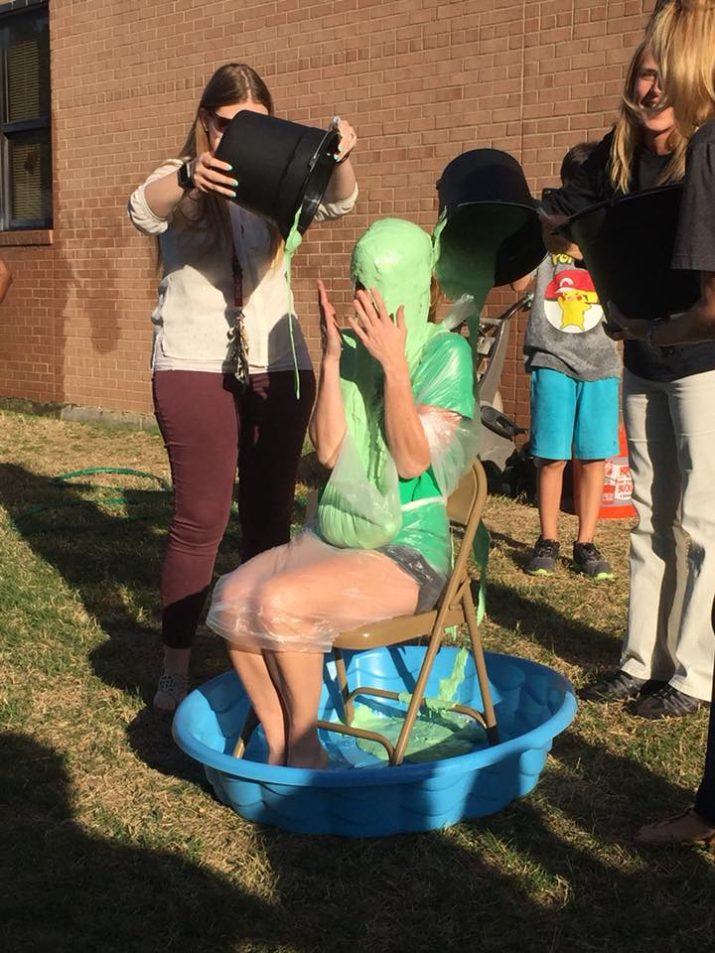

News



