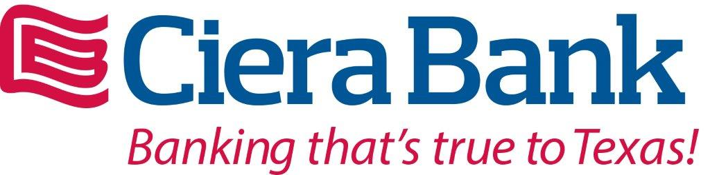



GRE PTA Corporate Sponsors

Membership Update

Thank you to all of our amazing Gator families! We exceeded our PTA Membership goal with 316 members as of the end of September. This is our highest PTA membership in 5 years! It’s never too late to join if you still want to. We had 8 classes that had 100% membership and they have won an ice cream party in October.

Mrs. Cooper, Mrs. Clark, Mrs. Scales, Mrs. Stewart, Mrs. Darling, Mrs. Taglieri, Mrs. Lyphout, and Mrs. Beck!

We also had the support of all the teachers and the entire staff at GRE join our PTA. Thank you to everyone for your PTA support. Together we can make a difference.

Sincerely,

Liz Hogg

Membership Chair

Book Fair

The Enchanted Forest Book Fair is almost here! We need your help! You can follow this link to sign up to volunteer! Don’t forget you must have a VOLY account set up to receive Garden Ridge opportunities in order to volunteer.

[Book Fair Volunteer](https://lewisvilleisd.voly.org/opportunities/view.html?id+AWYm5IOAyfL1-PcgsAbG)

Please don’t hesitate to email Jennifer Bassier with questions at [bookfair@gardenridgepta.org](mailto:bookfair@gardenridgepta.org)

Thank you for your support!



**Get Connected**

GRE PTA Website: [www.gardenridgepta.org/](http://www.gardenridgepta.org/)

GRE PTA Facebook: [www.facebook.com/GardenRidgePTA/](http://www.facebook.com/GardenRidgePTA/)

GRE School Website: [www.lisd.net/gardenridge](http://www.lisd.net/gardenridge)

GRE School Facebook Page: [www.facebook.com/gardenridge/](http://www.facebook.com/gardenridge/)

Join PTA: [www.joinpta.org/](http://www.joinpta.org/)



October 1st – 5th Grade Field Trip

October 1st – LISD FLO II Training

October 2nd – 3rd Grade Elm Fork Trip

October 4th – Picture Day

October 8th – No School

October 10th – Dennis Lee

October 10th – PTA Board Meeting

October 11th – Field Day & Color Run

October 11th – Fall Book Fair Begins

October 11th – Spirit Night @ Culvers

October 12th – Early Release

October 16th – Spirit Night @ Marcos

October 18th – 2nd Grade Hoedown

October 19th – Fall Book Fair Ends

October 22nd – October 26th – Red Ribbon Week

October 22nd – Box Tops Deadline

October 26th – PTA Fall Festival & Trunk or Treat

October 30th – Spirit Night @ Yogurtland

October 31st - Halloween

 

Donation Drive Results!

Our Hassel Free Donation Drive has concluded and we are astounded with the support our SUPER GRE Families have shown! We received $5,252 and an additional $975 from our Corporate Sponsors. Thank you all for your amazing support of our outstanding school!

News



We are going to have a SUPER Year!

